1. Introduction
The ipl_historical.csv dataset contains match-level information such as toss details, match results, playing XI, debut players, and winners.

2. Data Cleaning and Transformation
Step 1: Loading the Dataset
- The file ipl_historical.csv was imported into Power BI Desktop.
- Transform Data was selected to open the Power Query Editor.

Step 2: Changing Data Types
- Data types were assigned appropriately:
  - season, match_id, mom_player → Whole Number
  - toss_winner_choice, match_winner, match_result_text → Text
  - team1_playing11, team2_playing11, debut_players → List/Text

Step 3: Removing Invalid Match Records
- Rows where the match_winner column contained null or empty values were removed.

Step 4: Handling List-Type Columns
The following columns contain list values:
- team1_playing11
- team2_playing11
- debut_players
Some rows in these columns contain empty brackets [].
Meaning of []
- [] indicates a valid empty list
- It means no players exist for that category
- It does not represent missing or incorrect data

Step 6: Verifying Column Quality
- Column profiling showed:
  - 100% Valid values
  - 0% Errors
  - 0% Empty (for required fields)

Step 7: Applying the Transformations
- After completing all transformations, Close & Apply was selected.
- The cleaned dataset was loaded into the Power BI data model.

4. Conclusion
The ipl_historical dataset was successfully cleaned and transformed using Power Query.
Invalid match records were removed, while meaningful empty list values were preserved to maintain data integrity.

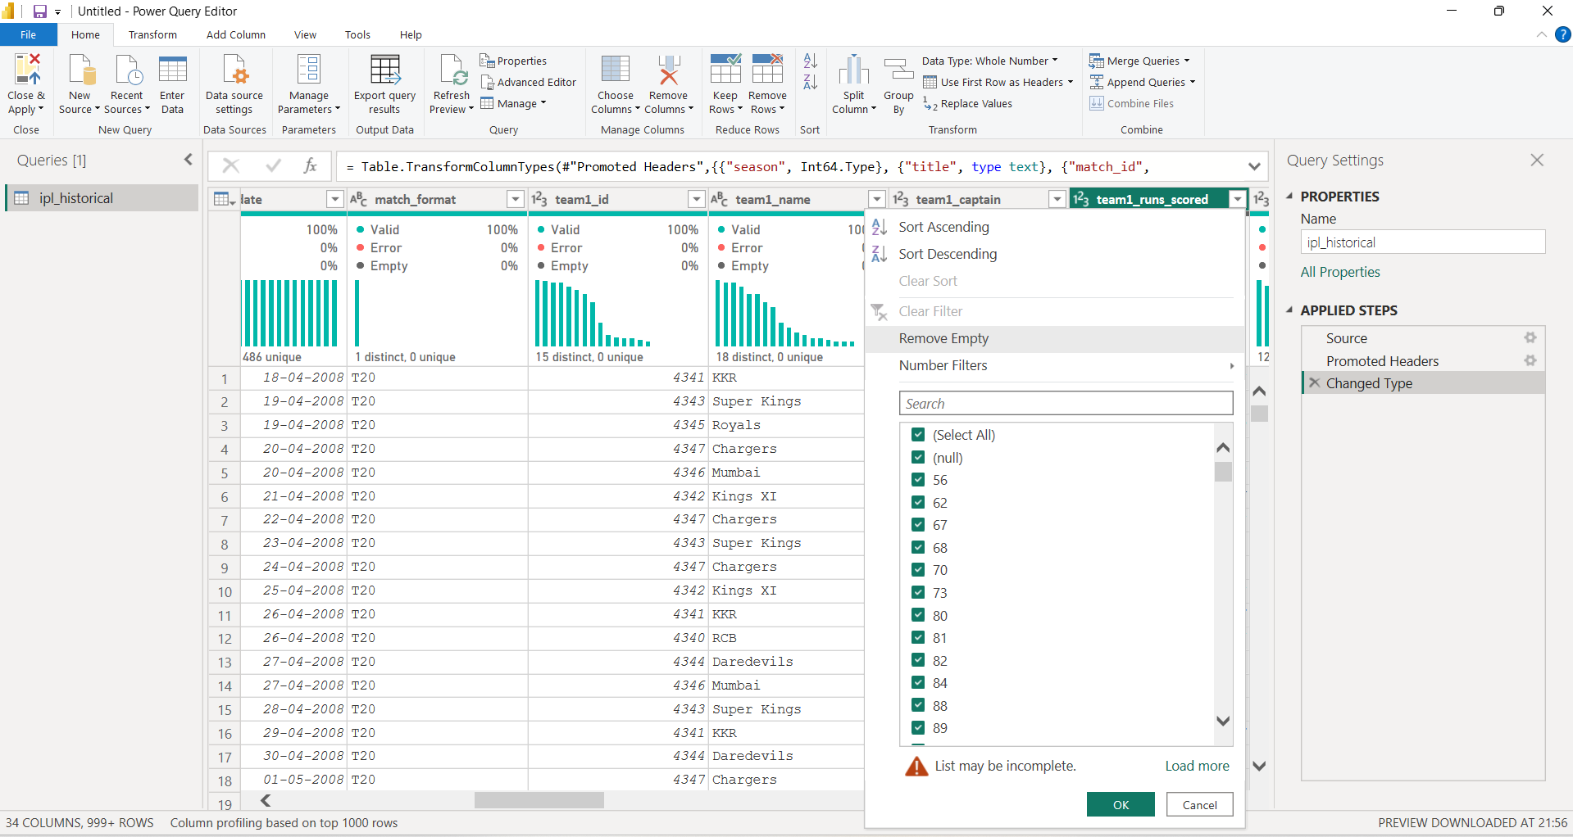1.Removing empty rows/columns
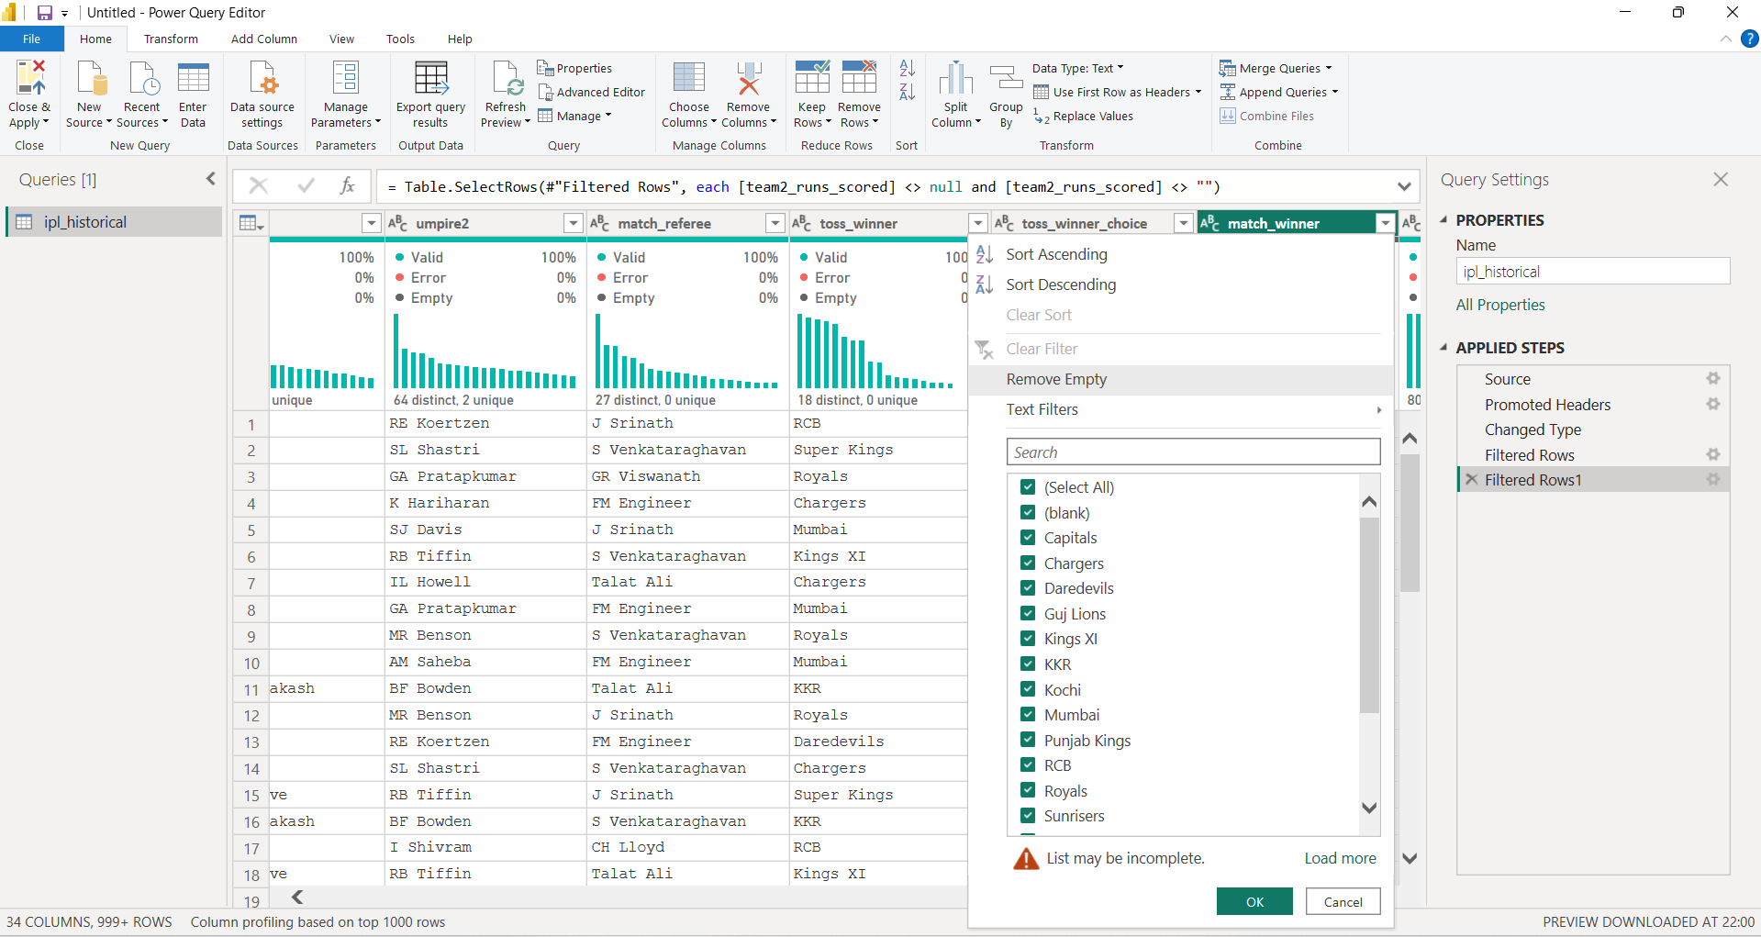

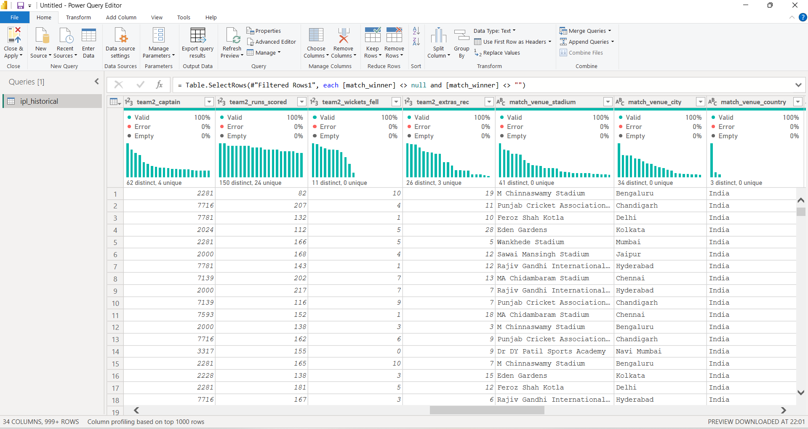
2.100% Clean data

